TVI CVI AHD IP CVBS CCTV tester

IPC-9800ADH Plus
◆ 7 inch IPS touch screen, 1280*800 resolution ◆5MP TVI, 4MP CVI, 4MP AHD test
◆ H.265/H.264, 4K video display via mainstream ◆ Dual window test, IP &Analog camera test
◆ Built in WIFI, create WIFI hotspot ◆ HDMI input and output,support1080p
◆ IP discovery , shortcut button, drop-down menu ◆ DC12V 2A, DC48V PoE power output
◆ Rapid ONVIF, auto view video and create testing report ◆ Quick office(excel ,word ,PPT format ) doc.
◆ RJ45 cable TDR test, cable quality test ◆ UTP cable tester
◆ TesterPlay: Tester, android version mobile phone, PC display at the same time

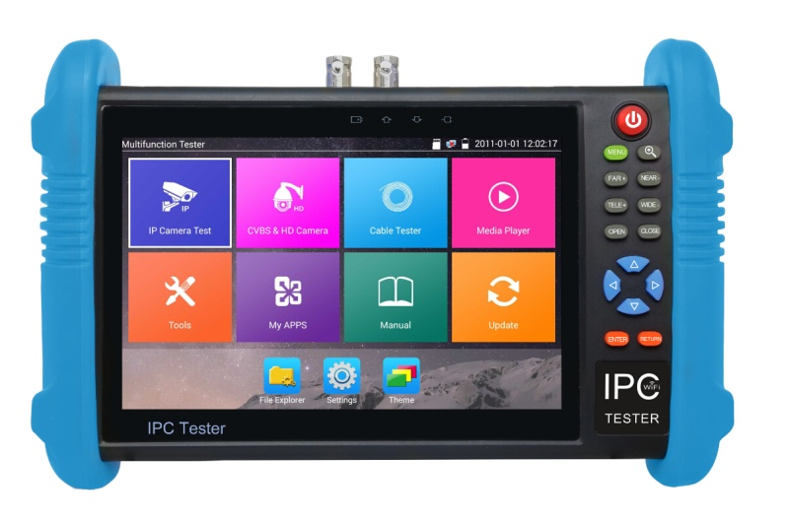
The 7 inch IPS touch screen IP camera tester is designed for maintenance and installation of IP analog, HD coaxial cameras as well as other security equipment. The 1280x800 resolution enables it to display network HD cameras and analog cameras in high resolution. The unit supports many ONVIF PTZ and analog PTZ control. Additional, it with other functions RJ45 Cable TDR cable test, UTP cable test and cable scan etc. CCTV installers often need to carry a variety of testing tools to complete their work. If take the all in one camera tester, making working conditions safer and increasing productivity.
Application

CCTV system installation and maintenance
Network cabling project installation and maintenance
Dome camera, IP TVI CVI AHD 4K H.265 camera testing
Video transmission channel testing
PTZ controller
Features

- New -7 inch IPS touch screen,1280*800 resolution
- New- H.264 and H .265 ,4K video display via mainstream
- New- 5MP TVI test,2560x1944P 12.5FPS,4xzoom ,video record and playback ,coaxial PTZ control and call camera OSD menu
- 4MP AHD test, 2560x1440P 15F/25F/30F,4xzoom ,video record and playback ,coaxial PTZ control and call camera OSD menu
- 4MP CVI test,2560x1440P 25F/30F, 4xzoom ,video record and playback ,coaxial PTZ control and call camera OSD menu
- IP & CVBS camera test, PTZ controller
- New- Rapid video, just by one key to detect all network cameras and auto display
- Rapid ONVIF, auto log in and display image from the camera, activate Hikvision camera, and also can create testing report
- New- IP and analog testing at the same time , converter test from analog to digital with dual test window IP & CVBS
- New- Screen management, change function’s icons order, create new directory
- New- Shortcut button, drop-down menu , can select PoE power ,IP setting, WLAN switch, HDMI IN functions etc in any interface
- Improvement cable tester, UTP cable, telephone cable etc order and connectivity test, can save testing report, if special number, need customized
- New- RJ45 cable TDR test, test cable pair status, length, attenuation, reflectivity, impedance, skew etc
- TesterPlay（screen projection）: tester, android version mobile phone and PC display at the same time
- New- Screen lock, password lock and pattern lock are optional
- New- HDMI signal input,720×480p /720×576p /1280×720p /1920×1080p /1024×768p/1280×1024p /1280×900p /1440×900p display image ,record and snapshot
- HDMI output ,support 1080P
- New- CVBS loop test , the tester send and receive color bar generator signal ,to check BNC cable
- New- Traffic monitoring of the tester "LAN port", display network port or WIFI connection real-time upload and download speeds and other network parameters
- New- Customers self update software ,you can install apps with android version ,such as Skype, wechat etc
- ONVIF camera test, support 2592*1520, Network PTZ controller (ONVIF)
- Built in Wi-Fi ,display image from the wireless camera , create WIFI hotspot
- New- 4K video files and MKV/MP4 media files play
- PoE DC48V power output, Max power 24W,12V /2A power output/5V 2A power output, as a power bank
- New- Quick office, quick office app ( support excel ,word ,ppt format ) doc. editable
- 8GB SD card including
- IP discovery, it can auto-scan the whole network segment IP, and auto-modify tester’s IP address
- Display its genuine resolution of the IP camera images
- Supports more than 30 protocols such as PELCO-P, PELCO-D, and SAMSUNG
- Enhanced Color bar generator, PAL/NTSC multi-system color bar video generator
- POE voltage measurement, PING test ,IP address scan, port flashing etc
- Audio in /out , support record and save the audio/LED lamp, calculators, music players and other application tools
- 7.4 V /5400mAh Lithium Ion Polymer Battery, after 5~6 hours charging , working time lasts 10 hours
Specifications

LCD | Item series | IPC-9800ADH Plus
 | Display | New 7 inch IPS touch screen ,1280*800 resolution
Video Mode | CVBS | 1 channel BNC input & 1 channel BNC looped output, NTSC/PAL (Auto adapt)
 |  | PTZ control,RS485 control, Baud 600-115200bps,compatible with more than 30 protocols such as PELCO-D/P, Samsung, Panasonic etc
 |  | CVBS loop test | the tester send and receive color bar generator signal , check BNC cable
 | IP camera test | IPC test /IPC viewer /Rapid Video/RTSP /ONVIF
 |  | Rapid ONVIF | Auto view the video, create testing report
 |  | IPC viewer | Support Mobile client (android version) of IP camera
 |  | Hik test tool | pressing just one key to activate hikvision camera , Image test, can modify the user name, password and IP parameters
 |  | Dahua test tool | Dahua camera test, modify the user name, password and IP parameters
 | IP& CVBS test | IP& CVBS test at the same time ,converter test from analog to digital with dual test window
 | Coaxial HD test | 5MP TVI camera test,2560x1944P 12.5FPS, UTC control/ call OSD menu
 |  | 4MP CVI camera test,2560x1440P 25F/30F,UTC control d call OSD menu
 |  | 4MP AHD test, 2560x1440P 15F/25F/30F, UTC control d call OSD menu
 | HDMI input | 1 channel HDMI input, support 1080P
 | Zoom Image | 4x zoom, to enlarge image, Screen snapshot, record ,save ,view and record and play back
Analog Video out | color bar generator | Output one channel PAL/NTSC color bar video signal for testing monitor or video cable
HDMI output | 1 channel HDMI output, support 1920*1080P
 | 12V/2A output | Output DC12V/2A power out ,supply temporarily power for the camera
Power output  cable test | PoE power output | 48V PoE power output, max power 24W
 | 5V/2A power output | USB 5V 2A power output, as a power bank
 | UTP cable test | Test UTP cable connection status and display on the screen. Read the number on the screen
 | RJ45 cable TDR test | test cable pair status, length, attenuation, reflectivity, impedance, skew etc
TesterPlay | screen projection：tester, mobile phone and PC display at the same time (For android version mobile phone)
Network test | Trace route, Link monitor , DHCP server, port flashing , Ping test
Wi-Fi | Built in WIFI,speeds150M,display wireless camera image
Audio test | 1 channel audio signal input, test whether sound normal, 1 channel audio signal, to connect headphone
Data monitor | Captures and analyzes the command data from controlling device，also can send hexadecimal
PoE test | Measurement POE switch or PSE power supply voltage and cable connection status
Drop-down menu | You can select PoE power switch ,IP setting, WLAN switch , HDMI IN functions etc in any interface
External power supply | DC 12V 2A
Battery | Built-in 7.4V Lithium polymer battery ,5400mAh
Rechargeable | After charging 5~6 hours, normal working time 10 hours
Operation setting | OSD menu, select your desired language: English, Chinese, Korean, Russian, Italian, French, Polish, Spanish, Japanese etc
Auto off | 5-30 (mins)
Working Temperature | -10℃---+50℃
Working Humidity | 30%-90%
Dimension/Weight | 240mm x 154mm x 46mm / 620g
A | AHD camera test, 5MP TVI camera test,2560x1944P 12.5FPS, UTC control/ call OSD menu
H | TVI camera test: 5MP TVI camera test,2560x1944P 12.5FPS, UTC control/ call OSD menu
D | CVI camera test : 4MP CVI camera test,2560x1440P 25F/30F,UTC control d call OSD menu

